**Brooklyn torah gazette**

**For parshas ki seitzei 5780**

Volume 4, Issue 47 (Whole # 199) 9 Elul 5780/ August 29, 2020

**Printed L’illuy nishmas Nechama bas R’ Noach, a”h**

**Rabbi Eliyahu de Vidas, zt”l**



**1776 printing of Rabbi Eliyahu de Vidas’s classic sefer Raishit Chochmah.**

R’ Eliyahu de Vidas z”l R’ Eliyahu was born in Tzefat in approximately 1550. His father passed away at a young age, and R’ Eliyahu grew up in extreme poverty. He studied under the two leading kabbalists of his day, R’ Moshe Kordevero (“RaMaK”) and R’ Yitzchak Luria (the “Arizal”).

When RaMaK passed away, R’ Eliyahu was entrusted with the deceased sage’s writings. Later, R’ Eliyahu settled in Chevron and became its Chief Rabbi. R’ Eliyahu is best known for his classic ethical work Raishit Chochmah.

Perhaps more so than any other popular mussar work, Raishit Chochmah delves into many esoteric and hidden matters, for example, a description of the punishment one may suffer in Gehinnom.

**The Chofetz Chaim Opinion on Raishit Chochmah**

A son-in-law of R’ Yisroel Meir Kagan (the “Chafetz Chaim”; died 1933) relates that his father-in-law used to deliver a mussar lecture to his students on Shabbat afternoons. Once he commented that people think that the description of Gehinnom in Raishit Chochmah is exaggerated, but that is not the case. Every word in R’ Eliyahu’s description should be taken as it is written, the Chafetz Chaim said.

One of the Chafetz Chaim’s students was gripped by terror when he heard this, and he fell ill. For a time, he seemed to be at death’s door, but he eventually recovered. He went to the Chafetz Chaim and he said, “Had I died, you would have been to blame.”

**Defends the Integrity of R’ Eliyahu’s Sefer**

The Chafetz Chaim rose to his full height and replied, “I say again – everything is exactly as the Raishit Chochmah describes. However, I do regret not adding one thing. If a person knew the extent to which suffering in this world can lessen the need for punishment in the World-to- Come, a person would gladly accept the suffering of Iyov (Job) all the days of his life.”

In Raishit Chochmah, Sha’ar Ha’yirah, R’ Eliyahu relates that in the month of Elul in the year 1570, he was visited in a dream by the soul of a man who had died about three months before. The soul told R’ Eliyahu, “Man is judged here and punished to a much more exacting degree than most people expect.”

Elsewhere in his work, R’ Eliyahu writes that a certain R’ Lapidot told RaMaK that he had seen R’ Yehuda bar Shushan in a dream and the latter’s face shown like the sun, and his beard glowed like a lamp, because he had never spoken idle words in his lifetime. R’ Eliyahu passed away in Chevron in approximately 1587. (Gedolei Hadorot)

*Reprinted from the Parshat Shoftim 5780 of the whY I Matter parshasheet of the Young Israel of Midwood (Brooklyn) edited by Yedidye Hirtenfeld.*

**Rabbi Berel Wein**

**On Parshat Ki Seitzei**

**By Rabbi Berel Wein**

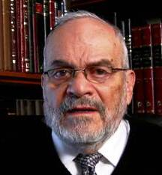

The Torah always views life as a struggle, a conflict between the various natures that exist within each human being, a fight between rational good and instinctive evil. Rashi points out in his commentary to this week's Torah reading, that the Torah is addressing itself directly to the evil instinct that lies within all of us and warns us. Even if we do not behave in an illegal manner, unpleasant consequences will always flow from actions taken impulsively and out of desire.

**The Danger of Purely Emotional Decisions**

Emotion is certainly necessary in life, but we know that purely emotional decisions often lead to sadness and even disaster. Thus, the taking of a non-Jewish woman captive as a wife, will have negative consequences, even if done legally and without any overt violation of the process that the Torah describes for us in the opening section of this week's reading.

Since it is a purely emotional, spur of the moment decision, there is a progression of events that will play out in later generations that will make it obvious that a poor choice was made originally. The next Torah sections describe the family structure, especially regarding monetary rights, rules of inheritance and finally wayward children who become unaccountable to their parents and as an existential threat to society generally.

**Responsible for All the Later Consequences**

Naturally, none of these consequences were foreseen at the original moment of passion that brought this non-Jewish woman into the family structure. She may be an innocent victim, in circumstances beyond her control, but the Jewish man who initiated the relationship is responsible for all the later consequences. The judgments of the Lord are infinite and hard to discern by human eyes. But there is no question that they exist.

Part of the reason for human behavior that is improper, which violates Jewish values and tradition, is the shortness of vision that our limited years impose upon us. Everyone aspires that their future generations should be people of worth, respect and value. Our greatest achievements always lie within our family. But there is no way that we can control the behavior of future generations or of our progeny. We can only serve as an example, and instruct and guide, and then hope that somehow all will come right.

**A Fundamental Problem in Life**

The rabbis were aware of this fundamental problem in life, and commented that children, meaning generations and how they turn out, are somewhat dependent upon elements of good fortune. We see throughout the Bible that the greatest and holiest people produce children or grandchildren that are ignoble and wicked. The commentators and scholars over the centuries have attempted to discern whether there was something in the behavior of the righteous parents or grandparents, some small failing that would allow and explain this sad phenomenon.

It is beyond our reach to be able to judge these things, but from this week's Torah reading and of Rashi's commentary, it seems apparent that even though generations may depend in the main upon good fortune, there is some element of cause and effect that exists and governs these situations.

The Torah was not given to angels, and all humans are imperfect. But when it comes to family and family matters, we must be very circumspect, for our behaviors have the ability to produce consequences far beyond any immediate decisions that we make.

*Reprinted from this week’s website of Rabbiwein.com*

**Parshas Ki Teizei**

**I’d Be the First to**

**Thank HASHEM, If…**

**By Rabbi Bentzion Shafier**

**Founder of TheSmuz.com**

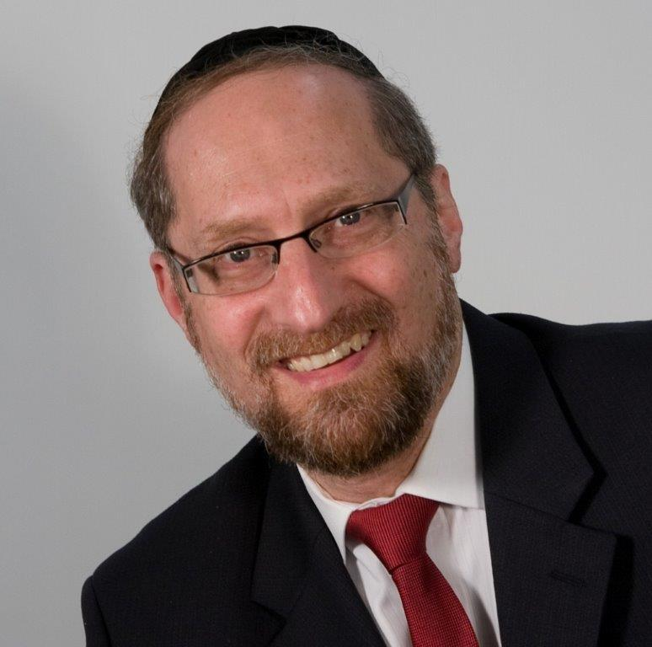

“*You shall not reject an Edomite, for he is your brother; you shall not reject an Egyptian, for you were a sojourner in his land.*” – Devarim 23:8

**Our Attitude Toward the Mitzrim**

The Torah lays out our attitude and approach to the different nations and tells us, “The Mitzrim cannot be totally rejected because you lived in their country.” Rashi is bothered by this mixed expression. If we are supposed to be grateful for the good that the Mitzrim did for us, why use the expression “don’t reject them?” This doesn’t sound very appreciative.

Rashi answers that the Torah is teaching us precisely that point. Our attitude towards the Mitzrim should be mixed. On the one hand, we don’t forget that they threw our infant boys into the Nile. On the other hand, they did provide a home for us. So we have ambivalent feelings. We don’t completely accept them, but we can’t reject them either.

When we think about the background, this Rashi is very difficult to understand. Our stay in Mitzrayim was not pleasant. Tortured and bled, oppressed and hounded, the Jew was treated far worse than a beast of burden. We had no rights. We had no life. We couldn’t choose our destiny or protect our children. What possible debt do we owe to them?

But even more telling is that the Mitzrim weren’t doing us a favor by allowing us to stay in their land. We were the backbone of their economy. Their entire production was based on slave labor, and we were the slaves. They didn’t feed us for our good; they did it so that we could produce for them.

They didn’t give us a place to sleep for our comfort; they did it so that we could be awakened at dawn, to the crack of the whip, to slave away in the sweltering heat. In plain language, we were property – owned by the Mitzrim, kept for their profit. Any good that they did for us was only for their selfish interests. Do we owe such people ha’karas ha’tov?

This question can best be answered with a moshol brought by the Chovos Ha’Levovos.

**The Ungrateful Teenager**

Two teenage brothers living in a grand estate are having a conversation. One says to the other, “Father is such a wonderful man! He is so generous with us, and so concerned for our good. Look at the entire program he has created for us – private teachers and tutors – all to benefit us. Everything that he does is focused on our betterment. I feel so grateful to him.”

His brother looks over and says, “Oh, I don’t know about that. First off, this getting up at 6:30 in the morning bit is a huge drag. And this whole ‘get an education routine’ is pretty lame. Not to mention five miles of running every morning! It’s just plain dumb! To tell you the truth, I’m not so sure he really has our good in mind at all. I think the old timer just wants to keep us out of his hair.”

What is the difference between the two teenagers? One is adopted; the other isn’t. You see, the adopted son grew up without. He knows what it means to suffer. Having had lived in an orphanage for two years, he knows what it is like to go to bed hungry, to sleep in a cold, dank cellar. When his adopted father took him in, everything was a vast improvement, so he has an unending sense of appreciation for what he now has. His brother, on the other hand, grew up in the lap of luxury. Since he first opened his eyes, all that he has ever known is comfort and abundance, and so none of it means anything to him. He is a spoiled brat.

**I Would Be the First to Thank G-d, If…**

The expression ha’karas ha’tov is highly illustrative of this concept. The word ha’karah means to recognize, to discern. Chazal were teaching us that this issue pivots on perception. By nature a person is grateful; the difficulty lies in recognizing what we have to be grateful for.

This seems to be the answer to this Rashi. There is no question that the Mitzrim’s motivation when they were playing host to the Jewish nation was not for the Jews’ benefit but for their own. However, the Jews did benefit. For 210 years they had a land in which to live, food to eat, and a place to sleep. In that sense, their very existence is attributed to the Mitzrim. Granted the Mitzrim didn’t intend for the good of the Jews, but the Jews were the recipients of it. For that we owe a debt of gratitude – albeit mixed – but a debt nevertheless.

The Torah is teaching us that if I have received something, I must recognize that, even if it is a mixed blessing. Therefore, while we don’t completely welcome the Mitzrim into our midst, we can’t reject them either.

One of the most motivating forces in our avodas HASHEM is a sense of, “I need to pay back.” How can I not do everything in my power to pay back the huge debt that I have to HASHEM? However, this is based on my understanding of the sheer amount of good that I receive. Unfortunately, we are a bit like the spoiled teenager who has everything and therefore has nothing. It is difficult for us to thank HASHEM. It isn’t that we don’t have; it is that we don’t perceive it.

When I train myself to appreciate the great wealth that I enjoy, I gain an automatic sense of wanting to pay back. By doing this, I enjoy my stay in this world to a much greater extent, I am grateful for what others do for me, and I have an unending sense of appreciation for all that the blessings I have received from HASHEM.

*Reprinted from this week’s website on TheShmuz.com This is an excerpt from the [Shmuz on the Parsha book](https://theshmuz.com/product/shmuz-on-the-parsha-book/).*

**The Falacy of G-d Ever Divorcing the Jewish People**

**From the Talks of the Lubavitcher Rebbe**

**Rabbi Menachem Mendel Schneerson, Zt”l**

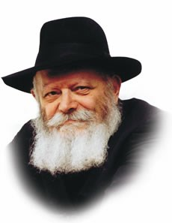

In this week's Torah portion, Teitzei, we read about the concept of divorce. In order for a Jewish couple to terminate their marriage, the husband must "write her a get (bill of divorce), and give it in her hand," i.e., the actual document must leave the husband's domain and be given over into the wife's.

Allegorically speaking, the Jewish people and G-d are likened to husband and wife, the "marriage" having taken place when the Torah was given at Mount Sinai.

**G-d Sent Her (the Jewish People) from His House**

Years later, when the Jewish people sinned, G-d "sent her from his house," i.e., banished them from the land of Israel, handing them, in effect, a "bill of divorce."

Yet how can we say that G-d "divorced" the Jews, when one of the principal requirements in the dissolution of a marriage is that the get leave the husband's domain and be given over into the wife's?

Is not the entire world G-d's domain, as it states, "The earth is filled with His glory"? Indeed, how can there be any domain that is separate from G-d?

The answer is that while G-d is certainly everywhere, His Presence in the world can be either revealed or hidden. When the Holy Temple stood in Jerusalem the Divine Presence was clearly manifest; ten open miracles perpetually proclaimed G-d's existence. It was a period in which the love between G-d and the Jewish people was open and apparent; His Presence in the world was palpable and easily perceived. During the exile, however, G-d "conceals" Himself, as it were, with the resultant perception of estrangement and disconnection from G-d.

**This Perception is Only an Illusion**

In truth, however, this perception is only an illusion, brought about by our misdeeds. When Israel sinned, G-d responded by "withdrawing," causing them to feel as if they had entered another domain, and thus validating the "bill of divorce." We must therefore bear in mind that the entire concept of the existence of "another domain" is fallacious; the "divorce" between G-d and the Jewish people is also an illusion. The Jewish people's alienation from G-d is only imaginary, the consequence of the darkness of exile.

Very soon, when Moshiach ushers in the era of Redemption, G-d's eternal love for His people will again be openly demonstrated, and the imaginary "divorce" between the Jews and G-d will have been annulled.

*Reprinted from the Parshat Ki Teitzei 5755 edition of the L’Chaim Weekly, a publication of the Lubavitch Youth Organization. Adapted from Likutei Sichot of the Lubavitcher Rebbe, Vol. 9*

**Making the Right Changes During Elul and How to Do It!**

**By Rabbi Moshe Meir Weiss**

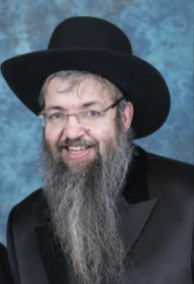

The month of Elul is synonymous with teshuva- repentance. It is also a time when we increase our charity as best as we can. Smart people also make a strong effort to patch-up friendships that have gone sour and to make amends with people they know they have wronged.

This is because even the holy day of Yom Kippur itself, with all of its afflictions and devout prayers, only atones for the sins between us and Hashem; the sins between us and our fellow man cannot be forgiven unless we appease the one we have hurt and acquired their forgiveness. It is for this reason that Elul is also a time for us to be magnanimous with our forgiveness of others for as good Jews we surely don’t want anyone to be punished on our account.

Do we really want someone to break a leg because they were nasty to us? Let’s remember that forgiving others is a form of compassion before Rosh Hashannah and Yom Kippur and as such it is highly effective in bettering our chances for a good year. This is because we are taught, “Kol hemiracheim al hebriyos merachamim alav min Hashamayim – Whoever has mercy upon others, Hashem will have mercy upon him from heaven.”

What if you find it difficult to forgive someone? Let’s say. for example, someone caused you to lose an exciting job opportunity, or perhaps they wrecked your chances at a good shidduch. How could you sincerely forgive someone who hurt you in such a terrible way?

**Make a Deal with Hashem**

Here’s a suggestion: Make a deal with Hashem. Say to Him, “Hashem, this person really was nasty to me. He really doesn’t deserve my forgiveness but I am willing to forgive him even though he doesn’t deserve it. Please, please forgive me for my sins even though I surely don’t deserve it.”

You might add the following afterthought: “Hashem I know that this person might even repeat such an offense against me in the future, but I am still willing to forgive him for now. Please forgive me as well even though I might likewise slip-up with aveiros, sins, sometime in the future.”

Elul is also the last month of the year. As such it is a very vital month, for our Chazal teach us that, “Hakol holeich achar hachasom – Everything goes according to the finale.” It therefore behooves us to make the last part of the year the very best part in every spiritual way, whether it’s davening, bentching, making brochos better, learning more Torah, spending more time with our spouse, parents and children, putting more thought into our tefillin, tzizis, mezuzah, being more careful with taharas mishpacha/family purity, kashrus, and Shabbos, and trying to find as many opportunities as possible to do a full array of gemilas chasadim/acts of kindness, such as visiting the sick, gladdening the hearts of brides and grooms, helping the needy, giving respect to the dead and showing special kindness to the widow, orphan, converts and the poor.

**We Must Petition Hashem to Forgive Us**

But there is another angle to Elul that many people do not realize. We are still acutely aware that at this time of the year and we must petition to Hashem to forgive us and a grant us a new lease of life. It is for this reason that we get up early in the morning to say the selichos prayers thanking Hashem for forgiveness, and we spend most of the Day of Judgment and of course Yom Kippur in solemn prayers, begging Hashem to give us another chance to be better people.

However, there is another side of prayer and that is to thank Hashem for all the wonderful things that He has given us during the past year. The central prayer that we say on the first night of selichos has a recurring stanza which goes like this, “Lishmoa el harina v’el hatefillah.”

We ask Hashem to listen to our songs and or petitions. Note that we mention song first because it is imperative that before we ask Hashem for future privileges, we first thank Him for all the things He has done for us in the past. It can be compared to the way we are with our older children when we spend a lot of money on them and devote much time to them.

**The Importance of Being Appreciative**

**And Having Gratitude to Hashem**

If they are appreciative and voice their gratitude, it is a pleasure to do more for them in the future. So too it is with Hashem. As the Chovos Halvovos succinctly puts it, “Devorim sherotzeh lehasmid bah, al tiftach bah – Things that you want to continue, don’t take them for granted.” Rather, constantly thank Hashem for all the kindness that He showers upon us, and then it will be a pleasure for Him to continue to do so in the future.

One of our national names is Yehudim, which means ‘people who give thanks’ for we understand the importance of expressing thanks at all times. This is why we start off every day of our life with the expression of Modeh Ani, thank you to Hashem, and every Jewish man says a whopping 100 brochos every day. (A women says fewer brochos because of other pressing responsibilities she needs to attend to.)

**It is Important to Look to the Future**

So as we prepare for the Day of Judgement, of course it is appropriate to look to the past at our misdeeds in order to repair them. It is also important to look to the future and make kabalos/new commitments on how we will try to do better. After all, we are not simply asking Hashem to grant us just another year.

We want an even better year and therefore we must in return bring to Hashem our commitments on how we too will do better for the upcoming year. But besides all of this, it is important to look back at out past year and take note of the many happy times we have had, the successes and the nachas, and make sure to say thank you to Hashem as we close the year of 5780. In that merit may Hashem bless us with a very healthy, happy, and wonderful New Year.

*Reprinted from the Parshat Shoftim email of the Jewish VUES.*

**A Moment in History**

**The Rebbe Rayatz Becomes An American Citizen**

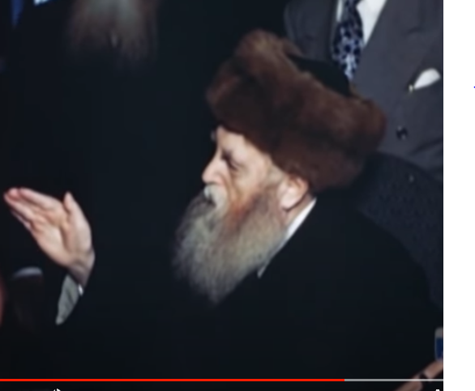

**Rabbi Yosef Yitzchak Schneersohn of Lubavitch (The Rebbe Rayatz, 1880-1950) taking the oath of citizenship in a special ceremony held in his private office at 770 Eastern Parkway in the Crown Heights section of Brooklyn on March 17, 1949, some 10 months before his petirah on January 28, 1950.**

**19 Facts You Should Know About Sephardic Jewry – Part 2**

**By** [**Menachem Posner**](https://www.chabad.org/search/keyword_cdo/kid/12145/jewish/Posner-Menachem.htm)

**9. Rabbi Yosef Caro Is the Final Sephardic Arbiter of Jewish Law**

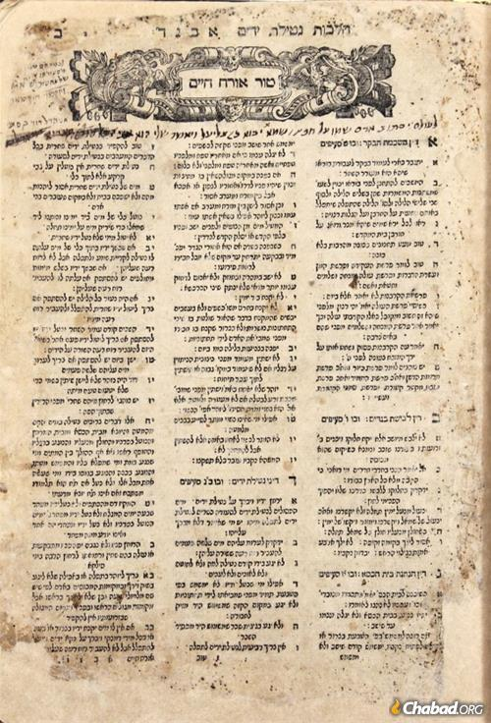

**The first page of the Shulchan Aruch, printed in Venice during the lifetime of the author.**

In the 16th century, Rabbi Yosef Caro, who was born in Toledo shortly before the expulsion, composed the Code of Jewish Law (Shulchan Aruch), in which he summarized and drew conclusions from the teachings of Maimonides, [Rabbi Isaac Alfasi](https://www.chabad.org/library/article_cdo/aid/112338/jewish/Yitzchak-Ben-Yaakov-Hacohen-Alfasi.htm) (Rif), and [Rabbi Asher ben Yehiel](https://www.chabad.org/library/article_cdo/aid/210832/jewish/The-Rosh.htm) (Rosh) in one highly-readable work.

While Ashkanazim often follow the rulings and insights inserted into the text by the Polish Rabbi Moshe Isserles, Sephardim are more inclined to act according to the rulings of Rabbi Yosef Caro.

**10. Sephardim Have a Unique Form of Hebrew Cursive**

Modern Hebrew generally appears in two forms: block and cursive. While contemporary cursive is similar to the script used for generations among Ashkanazim, it would have been illegible to Sephardim who favored an older form of Hebrew cursive that looks much more like what is now known as Rashi Script.

**11. Approximately Half of Israel’s Jews Are Sephardim**

In the first years after the declaration of the State of Israel, Jews poured in from the Muslim lands where they had lived for generations, having suddenly found themselves unwelcomed by their erstwhile neighbors.

In those years, they often faced discrimination and had a hard time integrating into a society where many of the bureaucratic and political leaders were filled by Ashkanazim. In recent decades, many of those old rifts have faded, and Israel’s Sephardim have risen in prominence.

**12. Sephardic Family Names Are Often Hundreds of Years Old**

[With notable exceptions](https://www.chabad.org/4825070#9), most Ashkenazi family names are only about 200 years old. Many Sephardim, on the other hand, have held onto their surnames for much longer than that. Thus, it is not uncommon for Sephardim to have names such as Toledano (“from Toledo”), Cardozo, and others that can be traced back to Spain.

**13. Sephardim Call Their Rabbis Chacham**

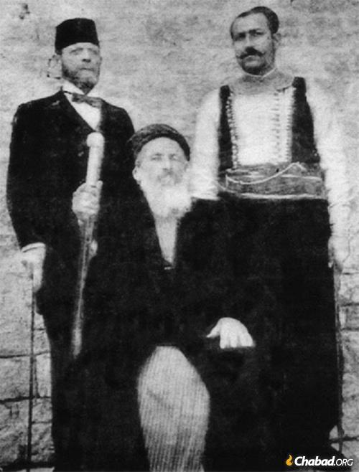

**Rabbi Jacob Saul Dwek, Chacham Bashi of Aleppo, Syria, 1908.**

Many Sephardic communities use the word *chacham*to refer to a rabbi. At its zenith, the Ottoman Empire encompassed large segments of the Sephardic world. As such, the chief rabbis of various major Sephardic population centers were known as *chacham bashi* (*bashi* is the Turkish word for “head”). In addition to providing spiritual and social guidance, the Chacham Bashi had legal standing as the representative of his community in governmental affairs.

**14. Sephardic Pronunciation Is More Nuanced Than Modern Hebrew**

There is a common misconception that Modern Hebrew, spoken in contemporary Israel, is the Sephardic Hebrew. This, however, is a gross simplification. While Modern Hebrew does have certain elements of Sephardic pronunciation (such as not differentiating between a *kamats* and a *patach,* or between a *tav*with a *dagesh*[dot] and one without), it also misses some important nuances of Sephardic pronunciation, such as the difference between be the *chaf*and the *chet*(which is pronounced gutturally) and between the *aleph*and *ayin,*which is pronounced as a velar nasal.

**15. The Majority of English Jews Were Once Sephardic**

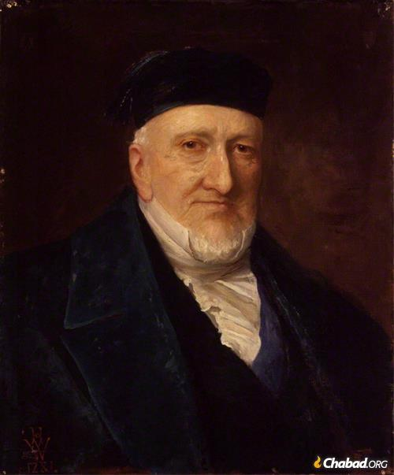

**Sir Moses Haim Montefiore was a British financier and banker who worked tirelessly on behalf of Jews everywhere.**

For centuries Amsterdam had a prosperous Sephardic community, made up primarily of Spanish Jews who came there by way of Portugal (until this very day, they still use Portuguese as part of their synagogue service). In 1655 Sephardic Dutch Rabbi Manasseh ben Israel of Amsterdam advocated successfully that Britain allow Jews back into its borders, almost 400 years after they had expelled their (Ashkenazi) Jews back in 1290. Jews began to trickle into England, and for a long time the majority of Anglo Jewry was of Sephardic stock. A prime example is Sir Moses Montefiore, the British knight who traveled the world to assist Jews everywhere.

**16. The First Jews in America Were Sephardim**

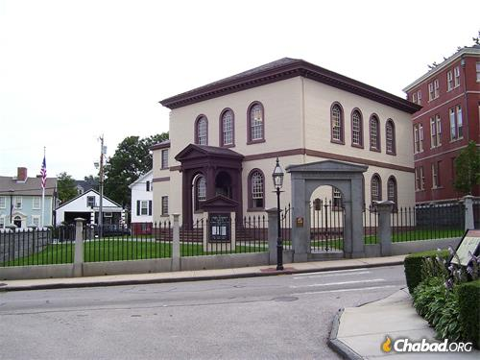

**2009 photo of Touro Synagogue in Newport, Rhode**

**Island, the oldest synagogue in North America**

It was no accident, some say, that Columbus set sail on the very same day that the Jews were expelled from Spain. Indeed, while there is much unresolved speculation regarding the provenance of Columbus himself, it is clear that his trip was financed by Jews, desperate to find a place they could live and worship in peace.

Over the next centuries, the Caribbean, Latin America, and even North America were settled by Sephardim. Thus, the first Jews in what would become the US and Canada were of Sephardic origin.

**17. Nusach Sepharad Is Actually Ashkenazic**

The traditional liturgy of Ashkenazi Jewry is known as Nusach Ashkenaz (Ashkenazi Rite). With the rise of the Chasidic movement, many began to incorporate various elements of the Sephardic rite into their prayers, since the Sephardic tradition was favored by the Kabbalists and more in tune with the meditations behind the prayers. This new Chassidic hybrid came to be known as Nusach Sepharad (or Nusach Arizal, since it conformed to the meditations of the Arizal).

Thus, a Nusach Sepharad synagogue is most likely populated by Ashkenazi Chassidim, and Sephardim prefer to refer to their rites as Eidot Hamizrach or Sephardi (with the added ‘i’) just to keep things clear.

**18. Sephardic Jews Have Unique Cuisine**



What Americans commonly refer to as Jewish food (chicken soup with kneidlach, kishke, potato latkes, sweet tzimmes etc.) is actually Ashkenazi food, which is not terribly dissimilar to the foods eaten by the gentiles in the lands where Ashkanazim originate.

Not surprisingly, these foods are unfamiliar to Sephardim, who enjoy an entirely different cuisine, reflective of the Mediterranean climate where they lived and prospered for generations.

**19. Reform and Conservative Are Virtually Unheard Of**

As social reforms swept through Western Europe, many Jews felt the pressure to “update” Judaism to conform with their newly acquired “enlightened” views. This led to the creation of Reform congregations, and by extension, Conservative ones, where the changes were not as drastic.

Sephardic Jews were largely untouched by those changes, and virtually all Sephardic Jews worship in the traditional Orthodox manner of their ancestors. By and large, even those Sephardim who have drifted from observance tend to be closer to tradition, with a warm place in their hearts for Torah, Torah scholars, and Jewish tradition.

(*Reprinted from this week’s email of Chabad.Org Magazine. To be continued in next week’s email edition*).